IoT Parking Management System

*“PARK-CON”*

Yuri Kim   
*Computer Science*  
*Daegu Catholic University*Gyeongsan, Korea   
[kyuri0215@cu.ac.kr](mailto:kyuri0215@cu.ac.kr)  
  
  
  
Hyewon Jo  
*Computer Science*  
*Daegu Catholic University*   
Gyeongsan, Korea  
[johyewon29@cu.ac.kr](mailto:johyewon29@cu.ac.kr)  
  
  
  
Sion Lee  
*Artificial Intelligence & Big Data Engineering*  
*Daegu Catholic University*  
Gyeongsan, Korea  
[sion1207@cu.ac.kr](mailto:sion1207@cu.ac.kr)  
  
  
Soojung Kim  
*Computer Science*  
*Daegu Catholic University*   
Gyeongsan, Korea  
[crystar2402@cu.ac.kr](mailto:crystar2402@cu.ac.kr)

line 1: 5th Given Name Surname  
line 2: *dept. name of organization (of Affiliation)*  
line 3: *name of organization (of Affiliation)*line 4: City, Country  
line 5: email address or ORCID

line 1: 6th Given Name Surname  
line 2: *dept. name of organization (of Affiliation)*  
line 3: *name of organization (of Affiliation)*line 4: City, Country  
line 5: email address or ORCID

*Abstract- Parking spaces are limited today, where the use of private cars is increasing. The problem of lack of parking space makes it difficult for drivers to find a parking space in an empty parking lot. Therefore, in this paper, to improve the driver's parking efficiency, an Arduino that can determine the presence of a vehicle in a parking lot using an ultrasonic sensor and an LED sensor is implemented, and this is visualized through a self-developed parking management system application. In addition,* *by establishing a database and server that works with the application and linking the application in the user's smartphone with Bluetooth beacons installed in the parking lot, this study suggests an IoT-based smart parking guide system that allows the user to identify and manage the parking space in the parking lot in real-time in order to find parking spaces easier than the existing parking method.*

Keywords- Arduino, Ultrasonic sensors, Beacon, parking lots, android application, Embedded system development, Parking management system

# Introduction

In modern society, the number of people using private cars is increasing and will increase further in the future as income levels are improved and automobiles are popularized due to rapid economic development. Drivers of vehicles will find that while cars have brought convenience to their lives, finding a parking space is the most inconvenient [1-2]. As the use of private cars increases, there is not enough space to park many cars, so the parking problem is also getting serious. Although the parking space is limited, the number of people who need it is increasing, which causes a problem [3].

Currently, where there is a large parking lot, such as a hypermarket or a shopping complex, the number of parking spaces is displayed at the entrance of each floor so that people can know how much parking space is left [1]. However, when entering the parking lot, the remaining parking space is counted to the number of fixed vacant spaces, such as parking spaces for the disabled or dedicated spaces for small vehicles. Therefore, there is a limit to securing a parking space by only checking the number of available parking spaces before entering the parking lot. And the biggest problem is that the driver must drive himself and find an empty parking space.

To reduce the time to find a parking space, an LED sensor is used in the upper part of the parking space so that drivers can see it from a distance. However, this is also the same situation in which the driver must search for a parking space himself.

In this paper, to solve the problem, Implement and propose an IoT-based parking application that informs whether there is an empty space so that the driver can conveniently find a parking space in a large parking lot. The application uses a Bluetooth beacon and an ultrasonic sensor to determine the location of a parking space and communicates with the server to display the information of the parking space in real time so that the user can conveniently find a parking space. Therefore, the purpose of this paper is to reduce unnecessary movement for drivers to find a parking spot, and to present an alternative for a fundamental solution to the parking problem.

The structure of this paper is as follows. Chapter 2 describes the existing research and related research for system implementation, Chapter 3 introduces the proposed system, and Chapter 4 describes the research results. Chapter 5 describes the conclusion of this paper and future research directions.

# Related Research

## Arduino

Arduino refers to boards (products) and related development tools and environments completed with a single board   
  
microcontroller based on open source. Fig. 1 shows the Arduino Uno. The Arduino Uno board has a total of 44 pins and terminals. Each pin and terminal can be used to control Arduino and other boards or sensors, and various applications are possible.

It can accept values from switches or sensors and create objects that can interact with the surrounding environment by controlling external electronic devices. It is also one of the embedded systems, which can be easily operated using the Integrated Development Environment (IDE). Furthermore, it is also optimized for implementing sensor-based Internet of Things because it can make various devices by connecting various sensors and components. This study proposes IoT-based parking management system based on Arduino-only sensors such as ultrasonic sensors and LED sensors.

## Ultrasonic Sensor

Identify applicable funding agency here. If none, delete this text box.

Ultrasonic sensors are industrial controls that measure and calculate distances from sensors to designated target objects using sound waves of more than 20,000 Hz outside the range of human hearing. The sensor fires an ultrasonic pulse and measures the ultrasonic wave reflected from the object again to measure the distance from the time the ultrasound flew. As an example of a system using ultrasonic sensors, a parallel ultrasonic sensor-based highway traffic rule violation detection application has been implemented to prevent traffic accidents and injuries [4].

The system proposed in this study uses Arduino's ultrasonic sensor, which facilitates measuring the distance of objects, to determine whether a parking lot available or not available. The ultrasonic sensor is shown in Fig. 2.

## Asynchronous Communication Method

Identify applicable funding agency here. If none, delete this text box.

Asynchronous communication is a method of transmitting in character units without synchronizing between send and receive. Asynchronous communication is simple to implement at a low cost, but it has a lot of overhead because it transmits start and stop signals at the time of data transmission. The   
  
aforementioned Arduino performs the Arduino sketch   
compilation and Arduino board upload based on the asynchronous communication method, Universal Asynchronous Receiver/Transmitter (UART) serial communication.

Identify applicable funding agency here. If none, delete this text box.

## Beacon

Identify applicable funding agency here. If none, delete this text box.

A Bluetooth beacon is a near field communication device that automatically recognizes a smart device at a distance and transmits the necessary data. It communicates with a user's smartphone through the process of reading the ID of the beacon and delivering the ID information to the server and transferring it to the smartphone [1]. Beacon is known for its BLE-based near-field data communication technology that prioritizes low power. The Bluetooth Smart (BLE) mode has two modes of communication (Advertise Mode/Connection Mode), and it communicates by continuously sending an Advertise Packet signal in Advertise Mode.

There are many relevant research examples of Bluetooth beacon-based positioning systems and their applications. It has implemented an iBeacon-based location system designed to enable remote control of equipment with indoor location and intelligent control system using low energy Bluetooth beacon and Internet of Things technology in order to control smart homes [5]. In addition, the iBeacon-based mobile indoor positioning system application for improved emergency room efficiency allows doctors and nurses to track and verify the patient's real-time location [6]. In addition, a beacon-based patient tracking system allows for tracking the patient's location and patient waiting status in the clinic, and provides visibility into the overall process through dashboards [7]. In addition, to enhance the management efficiency of on road parking, a low cost Bluetooth beacon-based on-road parking management system has been proposed to detect occupancy of parking spaces and vehicle identification [8]. Finally, there has been a case of developing a beacon-based disabled parking zone management system that enables non-contact wireless communication with the aim of ensuring mobility rights and promoting convenience for disabled people who have been disturbed by illegal parking. This is a system that checks whether the vehicle is parked by   
  
installing an ultrasonic sensor in a parking lot dedicated to the   
through Beacon's contactless radio recognition. [9]. This study proposes a mobile application that can efficiently check and manage parking lot seat information by receiving parking lot seat ID values through Bluetooth beacons. The Bluetooth beacon is shown in Fig. 3, and its model is the ibeacon E7, which can transmit signals up to 100 meters.

## Similar system

There exist proposals and implementations of several systems similar to IoT-based parking management systems covered in this paper.

First, the design of a parking management system using smartphones based on RFID and USN was proposed. A parking management system was implemented by connecting an ultrasonic sensor and an RFID module to an ATmega128 board equipped with a ZigBee module, a wireless network system. This allows users to check the parking lot located nearby through smartphone applications, and to check the empty parking space inside the parking lot and the location of the vehicle by the parked person in real-time. [10]. RFID, also known as electronic tags, is a technology that uses frequencies to identify IDs, and RFID technology is a technology that uses radio waves to recognize information from a long distance. RFID recognizes distances of up to 3m, while it is impossible to identify the interior position of the object and requires a separate reader. The aforementioned beacon has a difference in that it   
  
  
can recognize distances of up to 70m or more and can be located indoors and support all terminals of Bluetooth 4.0 or higher.

Secondly, a smart indoor parking lot management system using ultrasonic sensors and Bluetooth communication has been proposed. The system uses ultrasonic sensors from the parking lot sensor motes installed in each parking space to determine the occupation of the vehicle, and uses RSSI from Bluetooth to identify the location of the parked vehicle, recognizing the indoor location in real time to support the road service to the parked vehicle. [11].

Finally, an IoT-based parking management system was designed to detect vehicles and inform parking spaces to efficiently utilize parking spaces. The system designed a parking management system by constructing geomagnetic sensors, IR sensors, MCU, etc. to detect vehicles and IoT communication technology to deliver information to users. [12].

Based on the aforementioned similar systems, this paper proposes an IoT-based parking management system implemented as a mobile application using Arduino's ultrasonic sensors and LED sensors and Bluetooth beacons.

|  |
| --- |
| init  loop :  read US sensor  if detected :  update database |

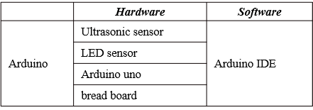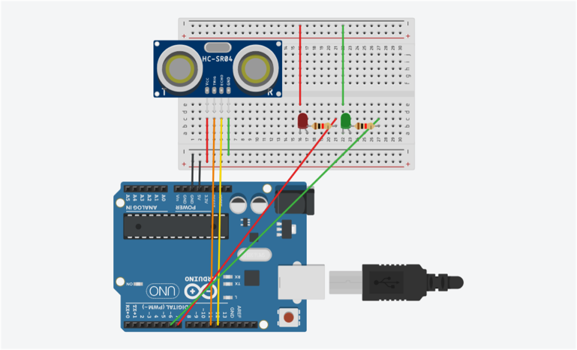Fig. 6. Arduino source code

|  |
| --- |
| init  read Beacon  connect to Parking server  read parking info.  display empty parking lot |

Fig. 9. Application source code

# Main Body

## research method

The diagram of the system proposed in this paper is shown in Fig. 4. When the driver who runs the parking management application PARK-CON enters the parking lot, PARK-CON, which detects the Bluetooth beacon, requests parking information from the server. The application requests parking information from the server, and at the same time, the ultrasonic sensor measures the distance to the vehicle and transmits the presence or absence of the vehicle to the server in real time. The server updates the parking information in the database in real time, and based on the stored information, the parking lot information is visualized and displayed in PARK-CON. Users can obtain parking information by analyzing parking lot information through the parking management application PARK-CON.

To proceed with the experiment, a simulated parking lot is made as shown in Fig. 5. A parking lot was made using an acrylic box and an Arduino board, and the parking sensor conducts an experiment using the TCP communication module on the Arduino board. The manufactured parking lot is arbitrarily divided into a space where three cars are parked, and an ultrasonic sensor is attached to the top of each parking space. It determines whether the corresponding parking space is parked in real time and transmits the measured data value to the server.

## Arduino implementation

The algorithm for determining whether the vehicle is parked in the proposed system is the same as the Fig. 6.

First, the method for judging the parking space is shown in Fig. 6. The ultrasonic sensor is used to read the distance value between the sensor and the vehicle, and the corresponding distance value is updated in the database. It determines whether there is a vehicle through the sensor and the distance value between vehicles stored in the database and allows the application to determine whether there is a vacancy in the parking lot.

The circuit diagram of Arduino to operate such a system is shown in Fig. 7, and the materials used are as shown in Fig. 8. After connecting the ultrasonic sensor and the LED sensor to the breadboard, connect it to the Arduino Uno. To operate the Arduino, a code was written so that the LED sensor is turned on according to the distance value of the ultrasonic sensor.

## Android application

To implement the application proposed in this paper, it was developed using Android Studio 4.1.1 version. The design of the application uses XML, and the operation of the application and the database link are developed using JAVA.

The operation algorithm of the proposed application is the same as the Fig. 9. Before entering the parking lot, the driver

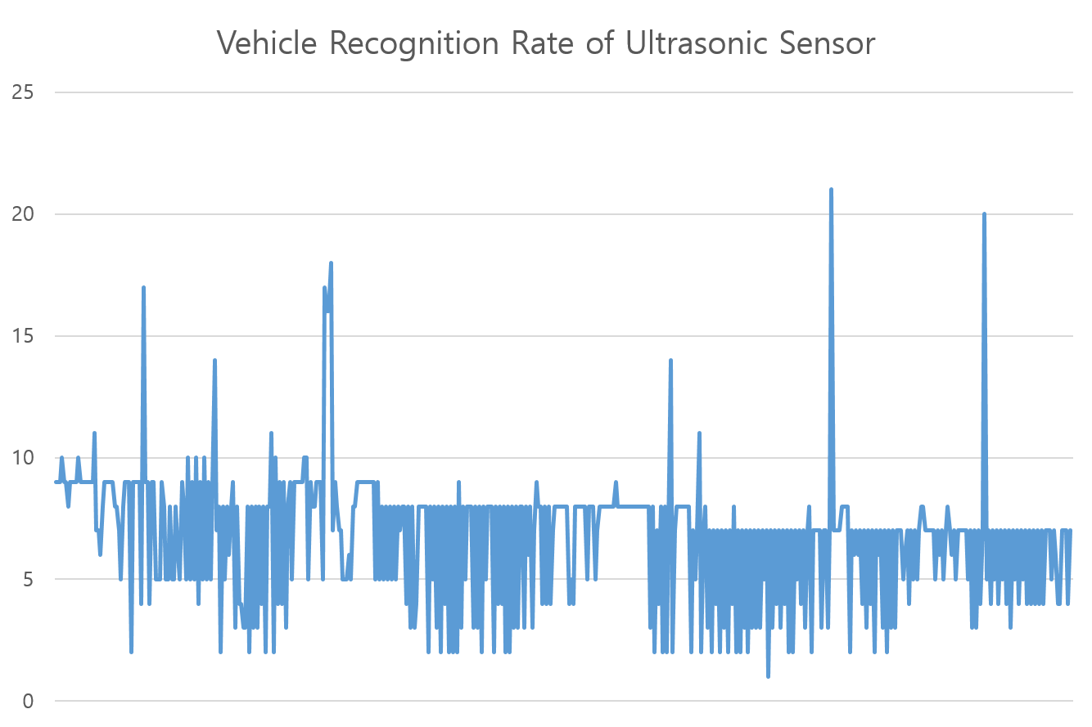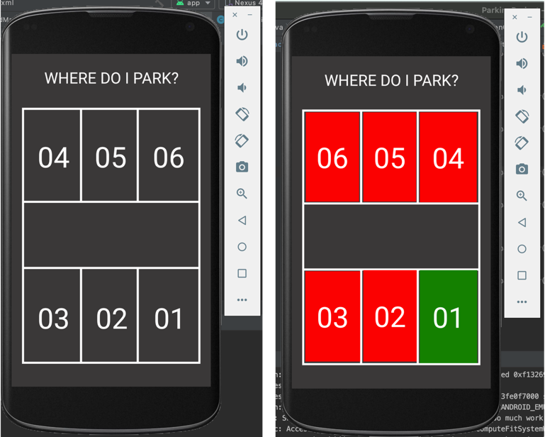

activates Bluetooth and runs the parking management application PARK-CON. When the driver's vehicle enters the parking lot, PARK-CON detects the Bluetooth beacon signal and requests parking information from the server. The server receives the value of the ultrasonic sensor in real time and updates it in the database, and the driver can check the information of the real-time parking lot with PARK-CON. PARK-CON displays the presence or absence of parking space as shown in Fig. 11.

Fig. 10 and Fig. 11 are the UI of PARK-CON. The application currently supports Android. Fig. 10. is the intro screen of PARK-CON, and 4 seconds after the application is executed, the intro screen is converted to the main execution screen. Fig. 11 is the main execution screen of PARK-CON. As shown on the right of Fig. 11, non-parking areas are marked in red and available in green to distinguish between available and non-parking areas.

# Results

The implemented algorithm to determine whether the vehicle is parked acquires the distance value through the ultrasonic sensor, updates it in the database, and causes the LED sensor to turn on according to the corresponding distance value. The red LED sensor turns on when the vehicle is parked, and the green LED sensor turns on when the vehicle is not parked. After that, the application can determine whether the vehicle is parked through the distance value stored in the database and check the parking lot vacancy information directly on the application screen.

To determine whether the corresponding system is operating, the recognition rate of the ultrasonic sensor and the accuracy of the ultrasonic sensor determining whether the vehicle is parked are important. First, the vehicle recognition rate of the Arduino ultrasonic sensor that determines whether the vehicle is parked showed a recognition rate of 96%, with 480 success recognition and 20 failure recognition among 500 experiments. Since the ultrasonic sensor is used to determine whether the vehicle is parked, the lighting of the LED sensor according to the distance   
  
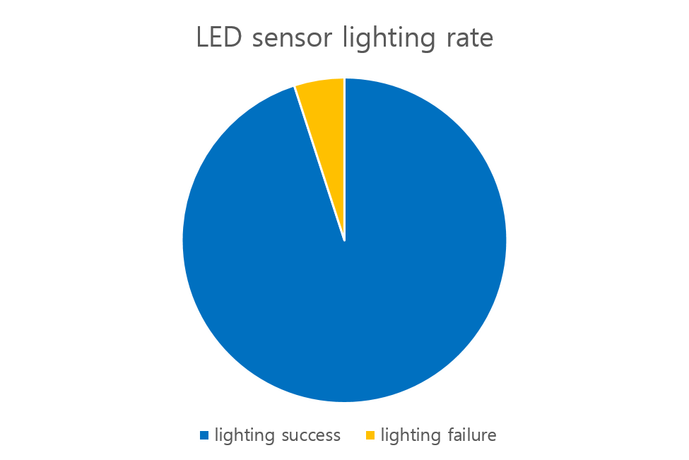value of the ultrasonic sensor is also important. Through the experiment, the lighting rate of the LED sensor according to the distance value of the ultrasonic sensor showed a recognition rate of 95% with 95 lighting successes and 5 lighting failures out of 100 experiments.

# Conclusion

In this paper, using an ultrasonic sensor, the distance is input in real time to determine whether the vehicle is parked, and the LED sensor of the parking lot is turned on according to the distance value. The LED sensor is implemented so that the red LED sensor turns on when the vehicle is parked, and the green LED sensor turns on when the vehicle is not parked. Based on the system mentioned above, the application is linked so that it can be determined whether or not the vehicle is parked, just as the LED sensor lights up according to the distance value in the parking lot. In order to implement this system, an application that determines whether a vehicle is parked can be implemented by combining the results of partial experiments. Furthermore, it can be applied in more diverse ways, such as presenting the remaining space in the parking lot and checking the location of the vehicle. Therefore, the future plan is to recognize license plates when leaving the parking lot to determine the hours of use of the parking lot. In addition, it is planning to expand its system to check whether parking is possible, check the location of vehicles, and figure out the number of remaining vehicles in the parking lot.

##### References

1. Y. W. Kim and I. H. Jeong, "IoT-based Smart Parking Guidance System", Proceedings of the Korea Information Processing Society Conference, vol. 22, no. 2, pp. 467-468, Oct. 2015.
2. T. J. Yoon, H. S. Kim, Y. J. Jeong and Y. H. Lee, “Development of Parking Area Image Recognition System Using Deep Learning Technique”, Journal of the Korea Society of Computer and Information, vol. 27, no. 1, pp. 301-302, Jan. 2019.
3. K. H. Lee and S. M. Park, “Study on Beacon-based Smart Parking Payment Service”, Proceedings of the Korea Design Society Conference, pp. 90-95, May. 2019.
4. Jun Liu , Jiuqiang Han,
5. Qinghe Liu, Xinshuang Yang, Lizhen Deng, "An IBeacon-Based Location System for Smart Home Control", MPDI, Vol.18, No. 6, 2018.
6. Xin-Yu Lin, Te-Wei Ho, Cheng-Chung Fang, Zui-Shen Yen, Bey-Jing Yang, Feipei Lai, "A mobile indoor positioning system based on iBeacon technology", Annual International Conference of the IEEE Engineering in Medicine and Biology Society, pp. 4970-4973, 2015.
7. Achim Escher, Maura Fithal, Marvin Marqua, Dominique Brodbeck, "Patiententracking mit Beacon- Technologie Pilotprojekt in einer radiologischen Praxis", Springer Medizin Verlag GmbH, ein Teil von Springer Nature 2019, pp. 114-149, Nov. 2019.
8. Chi-Fang Chien, Hui-Tzu Chen, Chi-Yi Lin, “A Low-Cost On-Street Parking Management System Based on Bluetooth Beacons”, International Conference on Advanced Information Networking and Applications, Vol.20, No. 16, pp. 471-480, Mar. 2019.
9. S. b. Yoon, Y. S. Lim, H. J. Jang, K. Y. Lee, "Parking Area Management System for Disabled Persons Using Beacons", Proceedings of the Korea Information Processing Society Conference, Vol. 27, No. 2, pp 534-537, Nov. 2020
10. M. j. Park, “USN-based Parking Management System”, Korean Society of Electronics Engineers Conference, pp. 1161-1163, November 2016.
11. Chungsan Lee, Youngtak Han, Soobin Jeon, Dongmahn Seo, Inbum Jung, "Smart Parking System Using Ultrasonic Sensor and Bluetooth Communication in Internet of Things", Korea Information Processing Society, Vol.22, No. 6, pp. 268-277, Jun. 2016.
12. P. S. Han, Y. Jun "IoT-based Parking Management System Design", Korean Electrical Society, INFORMATION AND CONTROL SYMPOSIUM, pp 156-159, Apr. 2017

**IEEE conference templates contain guidance text for composing and formatting conference papers. Please ensure that all template text is removed from your conference paper prior to submission to the conference. Failure to remove template text from your paper may result in your paper not being publish**